**LABSHEET 3: ASSEMBLY LANGUAGE PROGRAMMING OF**

**8085 MICROPROCESSORS**

**____________________­_______________________________________________________**

**Name: Aadithyan Raju Roll Number: AM.EN.U4CSE21301**

**___________________­­­­________________________________________________________**

1. Write the assembly program for the given object code where the starting address of the program is 4200H and the functionality of the ALP program.

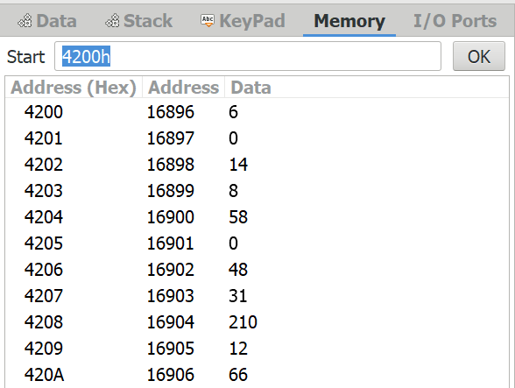

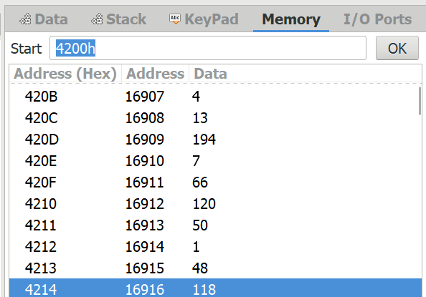

a)

|  |  |  |  |  |
| --- | --- | --- | --- | --- |
| Assembly | Instruction  Size | Memory  Address | Object Code in Hex | Flags or Register Flags change details |
| MVI B, 00H | 2 | 4200H  4201H | 06 00 | B = 00H |
| MVI C, 08H | 2 | 4202H  4203H | 0E 08 | C = 08H |
| LDA 3000H | 3 | 4204H  4205H  4206H | 3A 00 30 | A = FFH |
| RAR | 1 | 4207H | 1F |  |
| JNC 420CH | 3 | 4208H  4209H  420AH | D2 0C 42 |  |
| INR B | 1 | 420BH | 04 | B=B+1 |
| DCR C | 1 | 420CH | 0D | C=C-1 |
| JNZ 4207H | 3 | 420DH  420EH  420FH | C2 07 42 |  |
| MOV A, B | 1 | 4210H | 78 | A=B |
| STA 3001H | 3 | 4211H  4212H  4213H | 32 01 30 | 3001H = A |
| HLT | 1 | 4214H | 76 |  |

Note: Input data and the result of the program is in the following locations

. 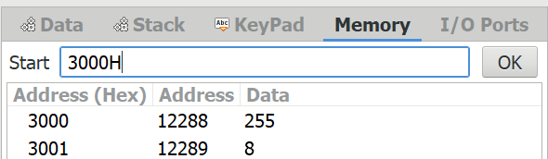

Show the usages of address bus, data bus, control bus and also the status of PC and relevant registers in the execution of each of the instruction.

|  |  |  |  |  |  |
| --- | --- | --- | --- | --- | --- |
| Assembly | Address Bus | Data Bus | Control Bus | PC | Flags or Register Flags change details |
| MVI B, 00H |  | 00 |  | 42 02 | B = 00H |
| MVI C, 08H |  | 08 |  | 42 04 | C = 08H |
| LDA 3000H | 3000 | FF |  | 42 07 | A = FFH |
| RAR |  |  |  | 42 08 | CARRY = A[0] , A[7-1]=A[6-0]  A[7] = CARRY |
| JNC 420CH | 420C |  |  | 42 0B |  |
| INR B |  |  |  | 42 0C | B=B+1 |
| DCR C |  |  |  | 42 0D | C=C-1 |
| JNZ 4207H | 4207 |  |  | 42 10 |  |
| MOV A, B |  | B |  | 42 11 | A=B |
| STA 3001H | 3001 |  |  | 42 14 | 3001H = A |
| HLT |  |  |  | 42 15 |  |

1. Fill the table for each of the assembly programs by selecting suitable instructions from 8085 Instruction Set. Show the output in 8085 simulators for the following programs and trace the program for 2 or 3 iterations. Explain each instruction and finally say what the program does.

|  |  |  |  |  |
| --- | --- | --- | --- | --- |
| Assembly | Instruction  Size | Memory  Address | Object Code in Hex | Flags or Register Flags change details |
| MVI A, 12H | 2 | 4200H  4201H | 3E 12 | A = 12H |
| MOV B, A | 1 | 4202H | 47 | B = A |
| MVI C, 03H | 2 | 4203H  4204H | 0E 03 | C = 03H |
| MVI A, 00H | 2 | 4205H  4206H | 3E 00 | A = 00H |
| ADD B | 1 | 4207H | 80 | A = A + B |
| DCR C | 1 | 4208H | 0D | C = C - 1 |
| JNZ 4207H | 3 | 4209H | C2 07 42 |  |
| STA 2001H | 3 | 420CH | 32 01 20 | 2101H = A |
| HLT | 1 | 420FH | 76 |  |

1. Mention the significance of Branch instruction JNZ. You can take the screenshot of register status in each iteration and copy it in the form of table.

MVI A, 12H

MOV B, A

MVI C, 03H

MVI A, 00H

Label1: ADD B

DCR C

JNZ Label1

STA 2001H

HLT

|  |  |
| --- | --- |
| Iteration1  A=18  C=2 | Iteration2  A=36  C=1 |
| Iteration3  A=54  C=0 | Final Result  Mem (2001H) = 54 |

1. Write an assembly language program using loops to add the numbers starting from 1 to 50. B=1+2+3+………..+49+50

LXI H,0

LXI D,50

L: DAD D

DCX D

JNC L

INX H

SHLD 2001H

HLT